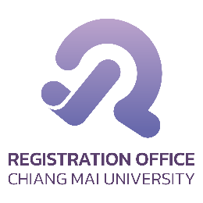
CMR.6
Thesis/Independent Study Examination Report
Examination Result of ☐ Thesis ☐ Independent Study
Student name Student ID .
Study in ☐ Doctoral Degree ☐ Master’s Degree Major .
Faculty Exam Date Exam Result as follows:
☐ Letter “S”, pass oral examination:
☐ Thesis/I.S. paper shows high quality and high standard. The thesis/I.S. examining committee have signed their names on the approval page and the Chairman will sign after the student has made the correction
☐ Thesis/I.S. paper is accomplished and has met the set standards but still requires some major correction. The Thesis/I.S. examining committee will sign the approval page following resubmission if the student and the Committee approve correction
☐ Letter “T”, student failed the oral exam and is allowed to retake an exam within six months from the date of the first exam.
☐ Letter “U”, student failed the oral exam and the thesis/I.S. is of poor quality. Student is required to re-register for the thesis/I.S. course.
☐ Other comments (If any) .

The Examining Committee

. Chairman
( .)

. Committee
( .)

. Committee
( .)

. Committee
( .)

. Committee
( .)

Thesis/I.S. Advisor or Advisory Committee

. Chairman
( .)

. Committee
( .)

. Committee
( .)

To Academic Program Chairman
Submitted for your information and further consideration.

(Signature) .
( )
Advisor
Date .

To Graduate Studies Chairman
Submitted for your information and further consideration.

(Signature) .
( )
Academic Program Chairman
Date .

To Director of Registration Office
Submitted for your kind consideration.

(Signature) .
( )
Graduate Studies Chairman
Date .

